Sherali Yadav Excel Challenge Report

1. What are three conclusions we can make about Kickstarter campaigns given the provided Data?

We can conclude from the Data that the three most successful categories for campaigns are Theater (61.28%), Music (79.41%), Film and Video( 57.69%).

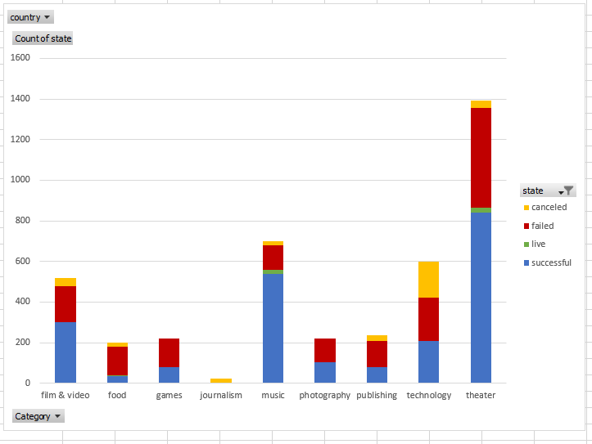

We can also conclude that during the end of the year the number of successful campaigns is decreasing. If you start a Kickstarter campaign in the end of the year it will have less of a chance to be successful than at the beginning. That would be something someone trying to start their campaign may want to think about. During which time of the year has a higher percentage of success.

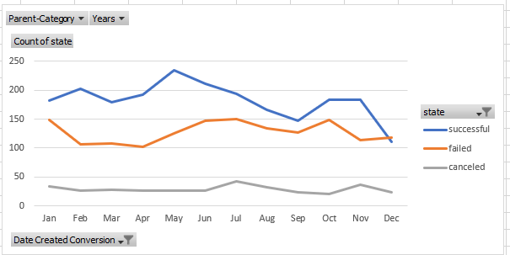

If we look at the data by each sub-category, we see that plays have more successful campaigns than the other sub-categories.

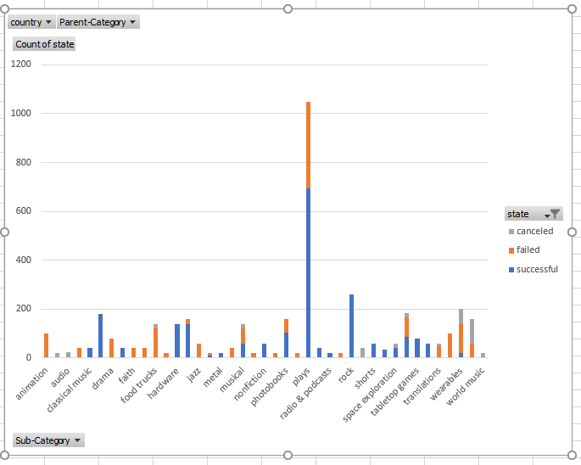

1. What are some limitations of this dataset?

There were some limitations to the dataset. There were some categories that did not have a large enough sample size that making it statically insignificant.

The categories/subcategories itself are also very broad and because of this we can only make broad conclusions as well.

1. What are some other possible tables and/or graphs that we could create?

We could create graphs based on categories and then each subcategory. This may help to analyze what is the most successful in each category.

We could try to analyze the amount of time the campaigns have to raise all the of their funds. And see how that time frame affects the success rate of the campaigns.